**Software Requirements Specification**

**Product – BLOG PLATFORM**

**By team TOOTHLESS**

# Introduction

## Purpose

This document provides a functional overview of a web based Blog platform and has to support the development and test planning processes of this project. Its goal is to present the scope, the basic content and the main functionalities that are supposed to be developed.

## Scope

The scope of this project is the creation of a blog platform with its main sections and sub sections, content, functionalities and design.

## Out of scope

On this phase of development we will not aim the integration of our product with other external systems as affiliation systems, commercials, payment gateways, etc. The categorization of the blog posts in separate topics, the restriction requirements and user agreements, detailed user profile attributes are also not in this scope.   
Reliablility, performance, supportability and licensing requirement would be in scope of the final phase of the project.

## Overview

The rest of this document contains the overall description of the blog platform and the specific requirements for the system.

# Overall Description

## Product Perspective

The blog platform will provide the possibility to all internet users to share their thoughts, knowledge, feelings and concerns. It will be absolutely free platform with no restrictions upon age, gender, race, country or religion. It should be user friendly and easy to use.  
The economical purpose of this product is to gain popularity, big number of commercials and wide network of affiliate collaboration.

Users has to register and login in order to use the platform. Every user will have its own blog profile. The user will be able to post blogs, read other user’s blogs and comment them.

## Product functions

### Offers personal blogging profile:

Every registered user is able to create personal blogging profile with user name, password and personal details.

### Offers personal blogging space:

Every registered user is able to create a blog topic and content and share them to the world.

### Offers the possibility to comment publications:

Every user can add a comment to any publication.

## Constraints

**The following are the constraints:**

* The project must be completed within the budget
* The project must be completed within a specified period of time.
* The system should be up 24/7.
* The system should enforce user authentication security and guarantee reliability.

# Specific Requirements

## Blog platform architecture and content:

### Authentication screen:

* Background – picture, slide etc. - MODAL FOR ALL PAGES
* Login section – pop-up:
  + Username
  + Password
  + LOGIN button
* Registration section – pop-up
  + Username
  + Password
  + Confirm password
  + Email
  + Full name
  + Profile picture
* Support contacts and development team details – MODAL FOR ALL PAGES

### Main navigation screen

#### PROFILE section

##### Edit profile pop-up

* + Old password
  + New password
  + Confirm new password
  + New email
  + New profile picture
  + New full name
  + SAVE CHANGES BUTTON

##### Log out – navigates back to the authentication page

##### User’s picture field

#### HOME section – leads to the main screen

#### ADD POST section

* Title field
* Description field
* Content
* Tags
* ADD POST button

#### ALL POSTS

* 4 windows with short versions of the first 4 posts are shown
  + title - clickable – opens the whole content of the chosen post
    - LEAVE A COMMENT
      * Name
      * Email
      * Comment
      * ADD COMMENT butto
  + author – clickable – shows all posts posted by the author
  + READ MORE button - opens the whole content of the chosen post
    - LEAVE A COMMENT
* Pages number counter – shows 4 posts per page. Clickable
* Tags dropdown with search button

3.1.2.5 LATEST POSTS – a window with the latest 5 posts listed

## Product main functionalities

### Registration and authorization

1. **Registration**. Users’ personal profile information input.
2. **Login**. Login to the platform with the created profile.
3. **Change password**. User is able to change the login password.
4. **Logout**. User leaves the platform

### Blog posting activities

1. **Create post.** User creates a personal blog with topic, short description and content
2. **Tags.** User is able to specify searchable keywords. The search engine searches in the title, the description and in the content

### Open post and comment

1. **Open post.** Users are able to open and read other users’ posts
2. **Search.** Search by keywords/tags
3. **Comment.** Users are able to leave comments to their own or other people’s posts

## Functional Requirements

We describe the functional requirements by giving various use cases.

*Use cases related to System Authentication:*

***Use case №1****:* Register  
*Primary Actor:* User  
*Precondition:*  Installed browsers and active internet connection.

*Main Scenario*:

1. Open a browser
2. Specify web address for accessing the blog platform
3. Navigate to the register section
4. A registration drop down should open.
5. Enter username – mandatory – at least 4 characters
6. Enter password – mandatory – at least 4 characters
7. Confirm password – mandatory
8. Enter names – optional
9. Enter profile picture link – optional
10. Click register button
11. System should accept the provided information and should create user profile
12. Successful registration message should be displayed

*Alternate scenario:*  
 11.1 Registration fails – incorrect input data in the mandatory fields

11.1.1 System should prompt registration failed message  
 11.1.2 System should allow re-entrance of the information

11.2 Registration fails – empty mandatory fields  
 11.2.1 System should prompt registration failed message  
 11.2.2 System should allow re-entrance of the information

11.3 Registration fails – username is already taken

11.3.1 System should prompt registration failed message  
 11.3.2 System should allow re-entrance of the information

***Use case №2****:* Login  
*Primary Actor:* User  
*Precondition:*  Installed browsers, active internet connection and created user profile.

*Main scenario*:

1. Open a browser
2. Specify web address for accessing the blog platform
3. Navigate to the login section
4. A login drop down should open.
5. Enter username
6. Enter password
7. Press login button
8. System should authorize successful login
9. The Main platform page should open

*Alternate scenario:*  
 8.1 Login fails – incorrect input data in the fields

8.1.1 System should prompt login unsuccessful message  
 8.1.2 System should allow re-entrance of the information

8.2 Login fails – empty field  
 8.2.1 System should prompt login unsuccessful message  
 8.2.2 System should allow re-entrance of the information

***Use case №3***: Change password  
*Primary Actor:* User  
*Pre Condition*: User is logged in   
*Main scenario*:

1. Click on the PROFILE section
2. A drop down should open
3. Click on the EDIT PROFILE button
4. Enter old password
5. Enter new password
6. Enter the same password in the Confirm new password field
7. Click on the Save changes button
8. A message for successful change should be displayed

*Alternate scenario:*  
 8.1 Authorization fails – wrong old password   
 8.1.1 System should prompt message for unsuccessful password change  
 8.1.2 System should allow re-entrance  
 8.2 Authorization fails – new password and confirm new password does not match   
 8.2.1 System should prompt message for unsuccessful password change  
 8.2.2 System should allow re-entrance  
 8.3 Authorization fails – new password and confirm new password are less than 4 characters   
 8.2.1 System should prompt message for unsuccessful password change  
 8.2.2 System should allow re-entrance

*Use cases related to blog posting:*

***Use case №1***: Create post  
*Primary Actor:* User  
*Pre Condition*: User is logged in   
*Main scenario*:

1. Click on the ADD POST section
2. A page with a posting form should open.
3. Enter title of the post in the Title field. Mandatory
4. Enter short description of the blog in the Description field. Mandatory
5. Enter the article in the Content field. Mandatory
6. Place preferable key words related with the article with which the blog can be searched by in the Tag field. Mandatory
7. Press the ADD POST button
8. A message POST ADDED SUCESSFULY should pop-up
9. The platform should navigates to the ALL POSTS section, the last post should stay on top

*Alternate scenario:*  
 8.1 Posting fails – one of the blog input fields is empty  
 8.1.1 System should prompt posting failure message  
 8.1.2 System should allow re-entrance

*Use cases related to opening posts:*

***Use case №1***: Open post from ALL POSTS section thru the post title  
*Primary Actor:* User  
*Pre Condition*: User is logged in   
*Main scenario*:

1. Navigate to ALL POSTS section
2. A page with the posts in short format should open
3. The posts should be listed by 4 posts per page
4. Under all posts there should be a page number counter that lists the postings pages content
5. When the desired post is found, click on the posting title
6. The post page should be opened

*Alternate scenario:*  
 None

***Use case №2***: Open post from ALL POSTS section thru the READ MORE button  
*Primary Actor:* User  
*Pre Condition*: User is logged in   
*Main scenario*:

1. Navigate to ALL POSTS section
2. A page with the posts in short format should be shown
3. The posts should be listed by 4 posts per page
4. Under all posts there should be a page number counter that lists the postings pages content
5. When the desired post is found, click on the READ MORE button
6. The post page should be opened

*Alternate scenario:*  
 None

***Use case №3***: Open post from LATEST POSTS screen   
*Primary Actor:* User  
*Pre Condition*: User is logged in   
*Main scenario*:

1. While located on the main page, find the LATEST POSTS screen
2. The latest 5 posts titles should be listed
3. Find a desired post and click on it
4. The post page should be opened

*Alternate scenario:*  
 None

***Use case №4***: Open post from the post author’s link   
*Primary Actor:* User  
*Pre Condition*: User is logged in   
*Main scenario*:

1. Navigate to ALL POSTS section
2. A page with the posts in short format should be shown
3. The posts should be listed by 4 posts per page
4. Under the title of every post the author’s username should be displayed and hyperlinked
5. Click on it
6. All of the author’s posts shall be listed

*Alternate scenario:*  
 None

*Use cases related to searching posts:*

***Use case №1***: Searching by tagged words  
*Primary Actor:* User  
*Pre Condition*: User is logged in   
*Main scenario*:

1. Navigate to ALL POSTS section
2. A page with the posts in short format should be shown
3. There should be a search box above the list with the posts
4. Click on the search box, a drop down menu with the tags should be listed
5. Chose the desired word
6. Click on the search button
7. All of the posts that content the desired word should be listed in the short format

*Alternate scenario:*  
 7.1 Search fails – if the search field is left blank

7.1.1 No results should be displayed on the screen

7.1.2 User should be able to use the search drop down again

*Use cases related to comments:*

***Use case №1***: Add a comment  
*Primary Actor:* User  
*Pre Condition*: User is logged in and opened a post  
*Main scenario*:

1. At the end of the post there should be LEAVE A COMMENT section
2. Enter Name - Mandatory
3. Enter Email – Optional
4. Write a comment in the Comment field – Mandatory
5. Click on the Add comment button
6. The comment should be shown under the post

*Alternate scenario:*  
 8.1 Comment fails – one of the mandatory comment input fields is empty  
 8.1.1 System should prompt posting comment failure message  
 8.1.2 System should allow re-entrance

## User screens

1. Authentication screen:
   1. LOGIN

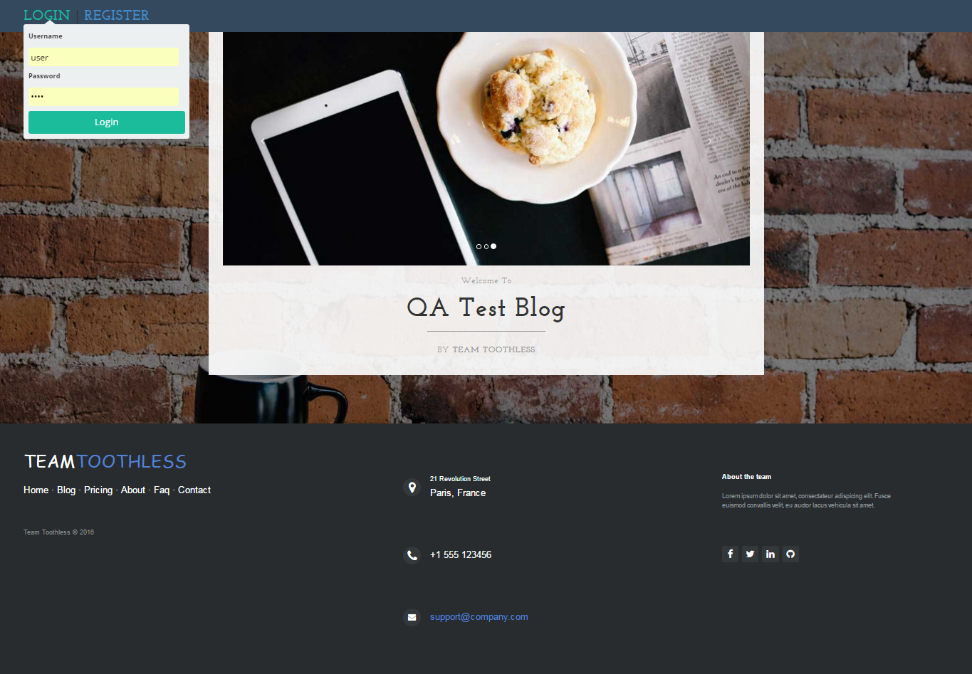

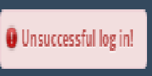

## Register

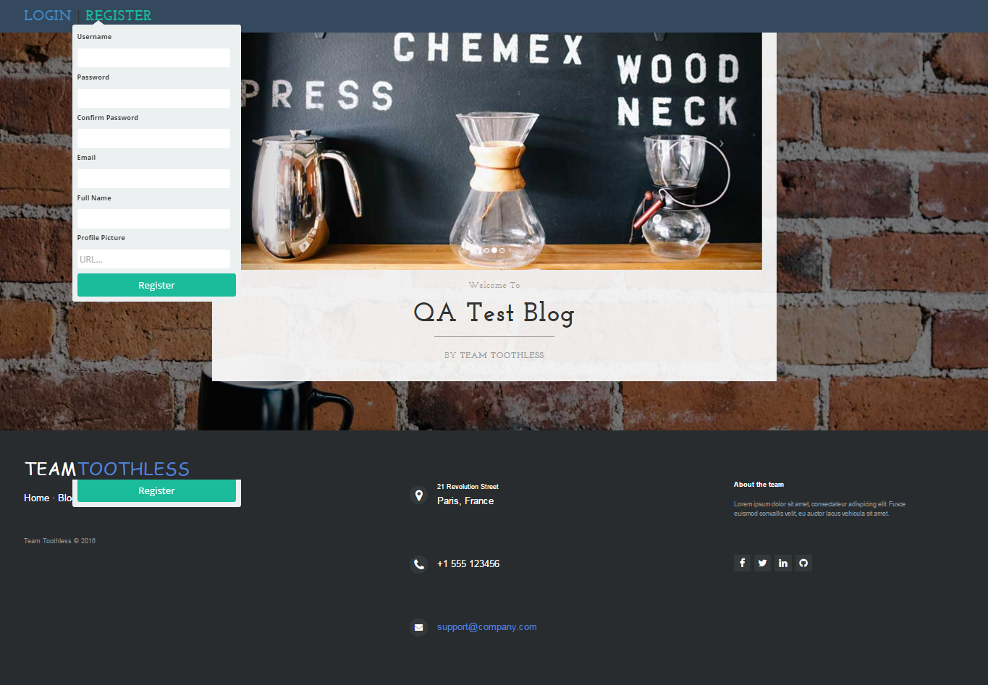

* 1. Change password:

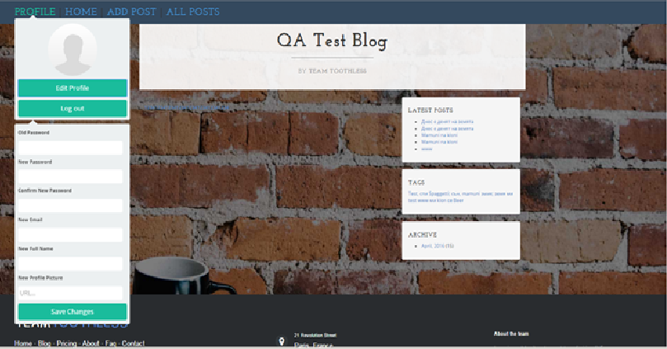

1. Opening an writing posts
   1. ALL POSTS screen:

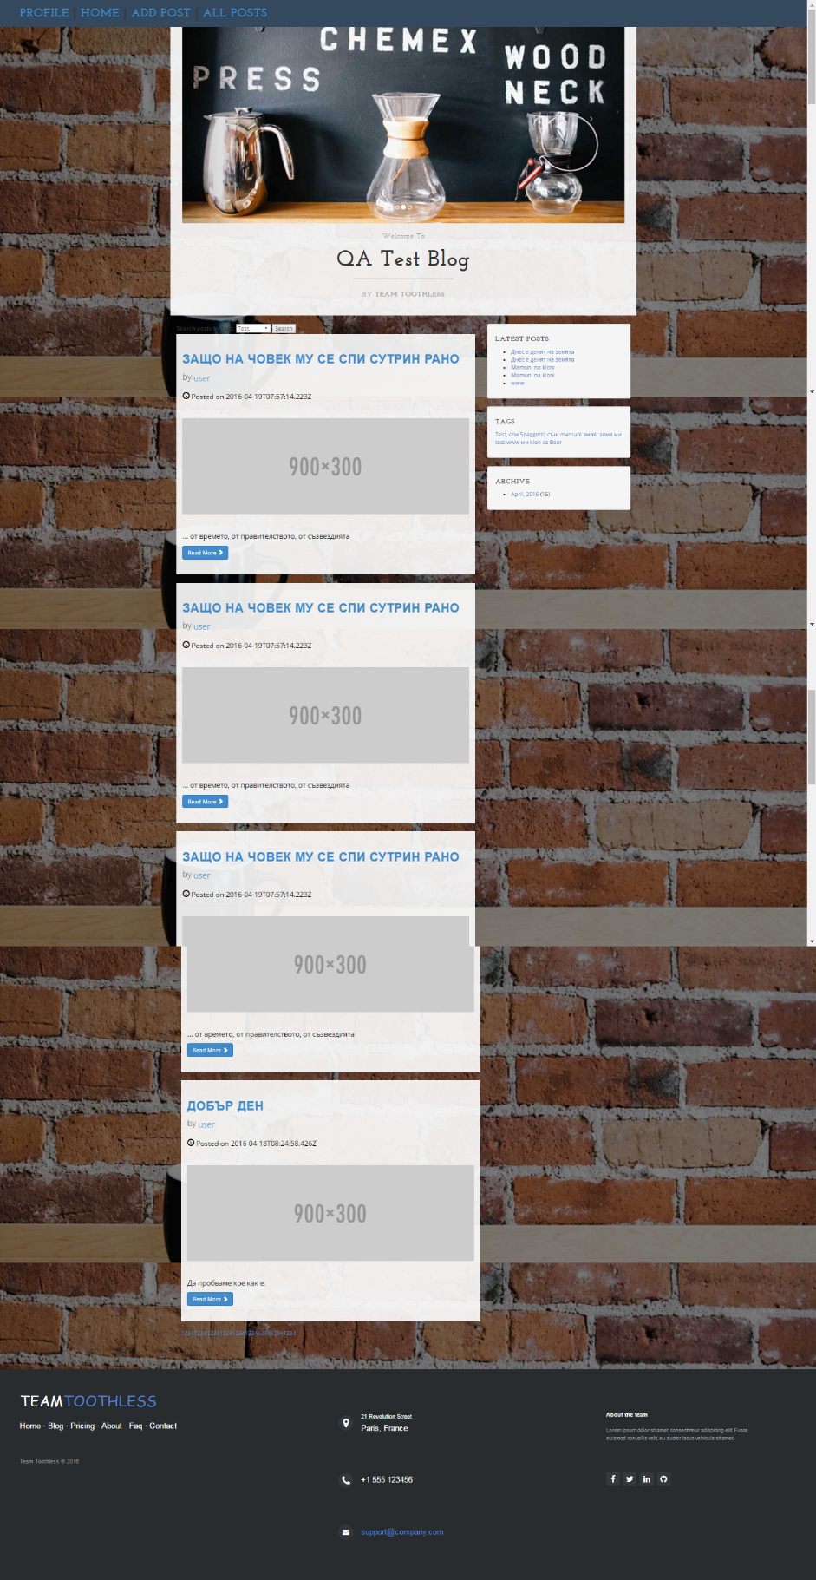

* 1. ADD POST screen:

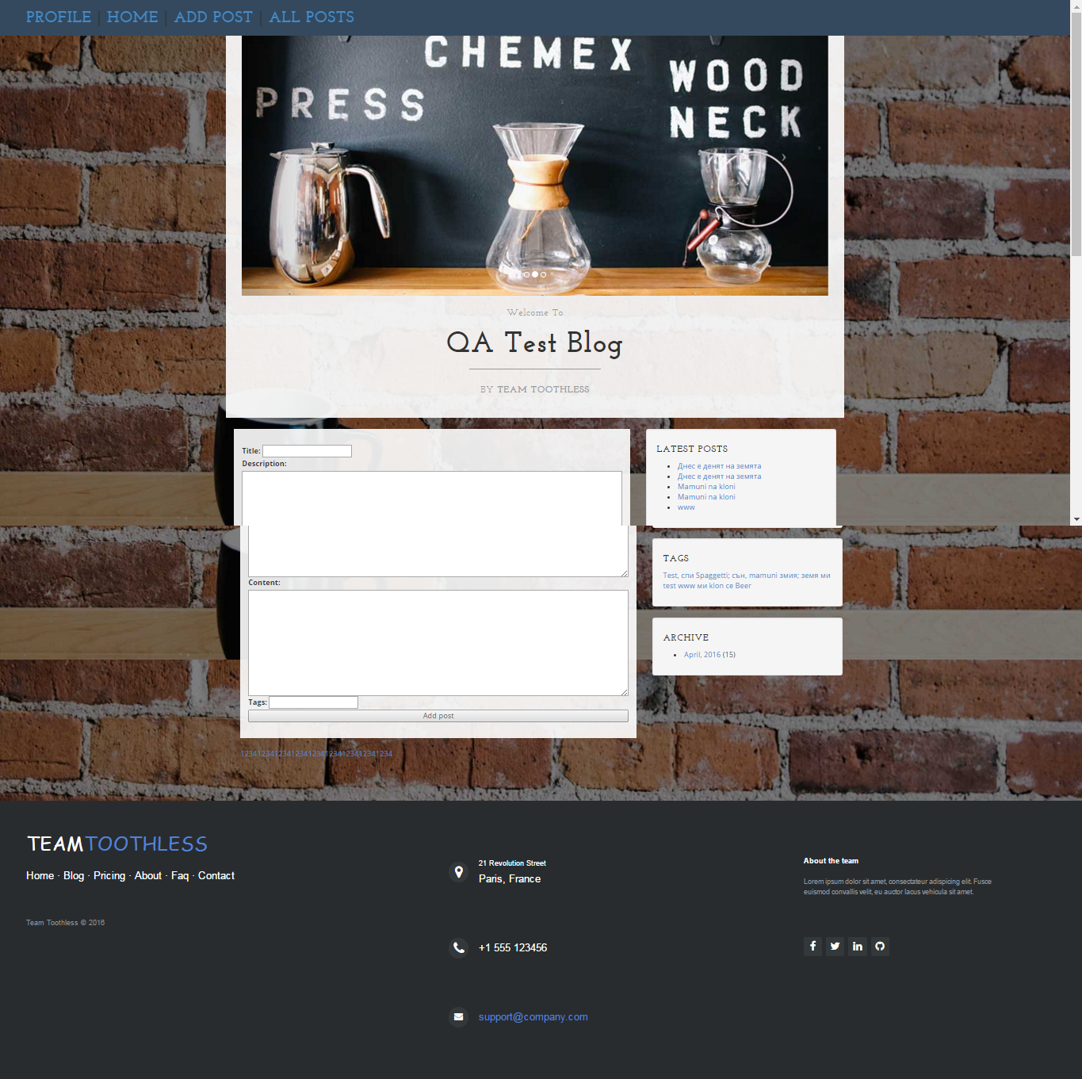

1. Comment post:

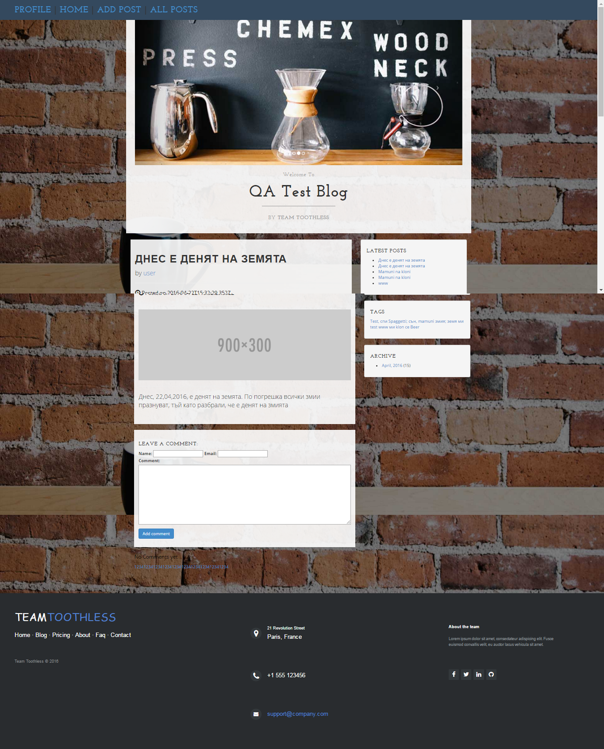

1. Search:

